**Undergraduate Final Year Project Proposal**

**Creating a Visual Language That Synthesizes Google Material Design on Rationalized Space and System of Motion Using Android App for Online Shopping**

**Student Name: Bui Quang Huy**

**Programme: Bachelor of Science (Honour) in Computing**

**[Your Banner ID]**

## Overview

Since the idea of computing machine, which we called ‘computer’ nowadays, started during 1940s of 20th century, we have been going through a miracle era of information technology (IT).

IT has changed our world a lot, and changed the way we live as well. Nowadays, with the prevalence of mobile devices like laptops, especially smartphones, as well as the high availability of high speed mobile broadband, everyone has a power to do anything they want anywhere and right off the bat.

The following situations are likely when:

* Someone is planning to buy something, but don’t know the place where to get it.
* Someone is thinking of buying stuff, but you don’t know about prices as well as designs.
* Someone are working, or doing anything. Suddenly, an idea comes to their mind, and they might just want to search for it for details immediately.
* Someone just wants to order small stuffs from the grocery store and have it delivered to their home, even at daylight or midnight.

The above circumstances are real, and possible. That’s why I want to create an online shopping app that enables people in those circumstances to fulfil their needs. In addition, this app is designed for Android smartphone according to the visual language that synthesizes the Material Design Language introduced by Google.

## Key phrases

Material Design, Visual Language, User Interface, User Experience, UI/UX, Smartphone, Android OS.

## Aim

The aim of the project is to create a Visual Language that synthesizes Google Material Design on rationalized space and system of motion using Android app for online shopping.

## Objectives

1. To study and understand the characteristics of Google Material Design, as well as the idea behind what Google states: “Material Design is a unified system that combines theory, resources, and tools for crafting digital experiences” (Material Design, 2017)

*Activities:*

* Read official documents and resources about Material Design which are published by Google.
* Examine popular Android apps which follow Marterial Design language, like eBay, Snapdeal and Amazon to see how their designs help to give a better experience to user.

*Deliverables:*

* Conduct Literature Review about similar products.
* Investigate methodologies, methods and programming languages: Java, XML, HTML, JavaScript, CSS, etc…
* Explore and write a report about various software development tools: Android Studio, Phonegapp, XAMARIN, etc…

1. To analyse the requirements of the developed app

*Activities:*

* Gather information from selected end users
* Analyse the information collected and create a requirements specification.
* Select an appropriate methodological approach for the project.

*Deliverables*:

Requirements specifications:

* List of functional requirements:
* List of non-functional requirements
* List of technical requirements

1. To design and develop an online shopping app that synthesizes Google Material Visual Language

*Activities:*

Create a UI design that complies with Material Design language

Choose a proper database for storing data.

Design and implement the app to meet the requirements

*Deliverables:*

Final UI Design. Database schema. Implementation code. Test plan. Results of testing. Evaluation of the app.

1. To test the developed app to make sure it functions well and meets requirements

*Activities:*

Create a test plan

Execute the app through each step of the plan and make document of the results

Fix the fail results if any

Publish the app using any one of the approach ( email;websit;google play store)

*Deliverables:*

Test plan. Testing results.

1. Write critical evaluation for the developed app

*Activities:*

Evaluate the entire project management approach

Evaluate how reliable and robust the developed app is

Point out the weaknesses and strength of the developed app

Compare the developed app with the existing app in the market in the manner of functions and UI design.

What could the app be improved in the future.

*Deliverables:*

Critical Evaluation.

## Requirements Specification:

* 1. **Functional Requirements:**

**5.1.1 Customer Functional Requirements**

**Product-related functions:**

* Customers can search for products by name using the app’s built-in search engine
* When looking through products, customers can add any product they want to the favourite list.
* Customers can add products they’d love to buy to the shopping cart.
* Customers might receive emails notification about important products.

**Payment-related functions:**

* Customers can perform checkout and purchase products listed in the shopping cart.
* Customers can provide the mailing and shipping address before purchase.
* Customers can choose the payment method they want: credit card or cash-on-delivery (COD)
* Customers can list all the orders they made.

**Login-related functions:**

* Customers have to create an account with their own email address or login using Google account (though Google API) and select ‘buyer’ for account type option.
* Customers’ data like personal info, payment methods, preferred app settings and products preferences must be saved to their account.
* Customers can see the list of favourite products they saved before.
* Customers can add/remove the favourites products.
* Customers can see the details of their shopping cart.
* Customers can modify the shopping cart.
* Customers can review the status of the orders they have made.
* Customers can log out of the app. Their personal info must be locally removed after logging out.

**5.1.2 Supplier Functional Requirements**

* Supplier have to create an account using their email address. This account must be ‘seller’ account type.
* Suppliers must provide information like: name, address, mobile, company…
* After logging in, suppliers and create, read, update and delete products that they are selling. These products will be attached with supplier id.
* Suppliers can search for the orders that include the products they’re selling. Orders without products they’re selling won’t be displayed as search results.
* Suppliers can print out the search results.

**5.1.3 Administrator Functional Requirements**

* Admin can login using predefined administrator account (username: admin)
* Admin can create, read, update and delete products.
* Admin can create, read, update and delete suppliers.
* Admin can modify user (customer and supplier) personal information: mobile phone, address, etc… but cannot modify username (email) and password.
* Admin can delete user account forever (remove from database) or just change the status of user account to inactive status. Inactive means user cannot login until it gets active again.
* Admin can search for products by product name, by product id, by supplier name or supplier id. Then admin can generate report for the searched results.
* Admin can search for suppliers by supplier id or supplier name. Then admin can generate report for the searched results.
* Admin can search for orders by suppliers or by users. Then admin can generate report for the searched results.
* Admin can also generate reports for daily transaction or products inventory.
* Admin can send email notification to specific customers/suppliers
  1. **Non-functional Requirements:**

**5.2.1 Performance requirements**

* The mobile app must be operating smoothly without crashes
* There is no delay between user’s gestures like scrolling up/down, swiping left/right to move between windows.

**5.2.2 Accuracy and Precision**

* The products information that must be accurate before and after user purchases.
* The amount of money that user see from the products and the amount of money that are charged from user must be exactly the same.
* The arriving time of the orders must be exactly and frequently updated.

**5.2.3 Modifiability**

* User can modify their personal info, even including deleting all of the info.
* User can modify the appearance of the mobile app: changing theme, colour, font size.

**5.2.4 Security**

* All the personal information from user must be encrypted and stored in the cloud.
* The database must be secured from attackers.
* User can turn on password protection for the app, so that the app must be provided with a password before being able to use.

**5.2.5 Usability**

* User can download the app directly from the Google Play Store
* User can easily get familiar with the app even in the first use.

**5.2.6 Legal**

* All the products presented in the app must be legal.
* Products that violate intellectual property rights or restricted from export must be prohibited.
  1. **Technical Requirements:**
* A smartphone that is running on Android 4.0 or above.
* Minimum resolution is 1024x768.
* An account on Google Play Store to download the app.
* An Internet connection is a must to be able to use the app.
* For better experiences, the app might need permission to access to user’s location so that it can provide location-based products to user.
  1. **Future Enhancement**
* To support mobile devices on iOS
* To support multiple languages according to the location of the app user (like English, Mandarin, Vietnamese, Malay etc…)

## Legal, Social, Ethical and Professional

Things are changing fast in today world! This requires every business to adapt quickly to changes to be able to get a competitive position in the market. In order to do that, organisations need to carry out projects. A project is a process including many activities that will be undertaken to produce a product, or to achieve a particular aim that fulfils business needs. In order to keep everything like cost, time, resources in order, and to guarantee the success of the project, a project manager is necessary.

Project manager is responsible for the entire project. This person has the highest priority to make every single decision: selecting methodology to approach the project, assigning tasks to team members and communicating with the key stakeholders. In other words, he/she have significant opportunities to do the right things or cause harm.

In fact, project managers usually make mistake. Sometimes by accident, but sometimes intentionally. Examples of regular mistakes are:

-    Not pulling their weight on projects, allowing them to drift, abdicating all responsibility to the sponsors and senior managers.

-    Accepting their brief as doing only coordination and clerical work, not really driving projects.

-    Being too willing to accept whims and fancies of the most influential or most vocal stakeholders allowing them to hijack projects.

-    Failing to report the true picture to all stakeholders.

(Shouche, 2008)

Therefore, there must be a list of fundamental principles that the project manager or any other single individuals involving to the project must follow, in order to avoid the ‘conflict of interest’ as well as guarantee the ‘public interest’.

As stated in the book “Ethics for the information age” by Michael J. Quinn, the list of fundamental principles should include at least the following manners:

* Be impartial
* Disclose information that others should know
* Respect the rights of others
* Treat others justify
* Take responsibility for your actions and inactions
* Take responsibility for the actions of those you supervise
* Maintain your integrity
* Continually improve your abilities
* Share your knowledge, expertise and value

(Quinn, 2009)

However, in the circumstance of an undergraduate project, I’m the only student that will be responsible for the entire project, with the help from my teacher-supervisor. Therefore, I create my own principles list that I found suitable for me, as following:

* Accept full responsibility for my project. This means I will take responsibilities for planning, designing and implementing the project to achieve 2 goals: successfully produce required deliverables and submit the project report on time.
* Keep working frequently with my supervisor to ensure the progress of the project.
* Being honest to my supervisor about my limitation of experience and knowledge, as well as the difficulties that I would be facing during the progress.
* Do not use any illegal resources or resources that are obtained illegally, like laptop, materials in library, unauthorized software.
* Use the property only in ways properly authorized and with the owner’s consent: books from library, computers in the school labs.
* Improve my understanding of project management, IS analysis and design as well as programming skills.
* Improve the ability to produce informative and correct specifications and documents

## Time Planning

The very first concern when starting a project is management. A project always involves many stakeholders and requires many resources like time, cost, human and of course, these resources are limit. Hence, there must be a method for the project manager to control resources effectively and guarantee success.

Today, there are two most important and popular project management methods: PRINCE II and PMI’s PMBOK (Rad, 2013). There are several differences between these two, but the most significant difference is that PMP is actually kind of a standards, not really a methodology. It introduces general concepts and techniques to evaluate the methodology we use to proceed the projects.

On the other hand, PRINCE II is a truly methodology which includes many process models, techniques and tools that will guide the project manager to run the project step by step. Therefore, It’s more practical than PMI’s PMBOK. That’s why I decided to focus more on PRINCE II to cover the planning lifecycle of this project. However, I still used PMI’s PMBOK as a reference.

One of the handy planning tools from PRINCE II is the Product Breakdown Structure, or Work Breakdown Structure (WBS). With WBS, the project will be broken down into multiple small tasks, each of which will be undertaken to achieve a single sub-product. These sub-products could be paper based products, quality products or sub-components of the final system/software. Then all of the work breakdown units will be visually presented in a form of a hierarchy. This brings some benefits:

* The final product is deconstructed into smaller components, making it easier to manage and develop.
* The project can be organized into parent-child relationships. That means the project can descend until the project team is confident that all requirements are accounted for (Productbreakdownstructure.com, 2017).
* The WBS is a visual presentation of summarized information, so it’s easy to share across the project teams during progress.

This is the list of WBS I created for this project. I organized them into a Gantt Chart for time plan.

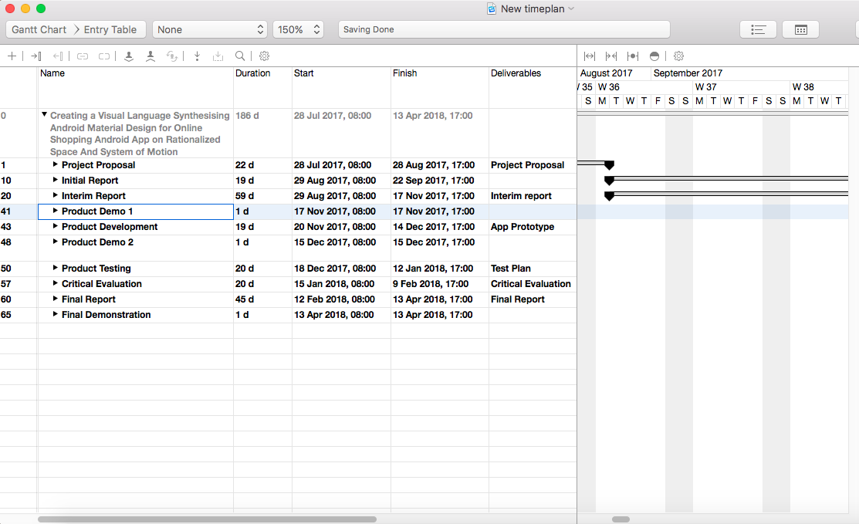

## Initial References

#### Material Design. (2017). *Material Design*. [online] Available at: https://material.io/ [Accessed 16 Aug. 2017].

Productbreakdownstructure.com. (2017). *PRINCE2 | Product Breakdown Structure*. [online] Available at: http://www.productbreakdownstructure.com/pbs-according-to-prince2.php [Accessed 28 Aug. 2017].

Quinn, M. (2009). *Ethics for the information age*. Boston: Pearson/Addison Wesley, p.390.

Rad, N. (2013). *Planning Lifecycle in PRINCE2*. [online] Project Smart. Available at: https://www.projectsmart.co.uk/planning-lifecycle-in-prince2.php [Accessed 22 Aug. 2017].

Shouche, S. (2008). Ethical project management. Paper presented at PMI® Global Congress 2008—Asia Pacific, Sydney, New South Wales, Australia. Newtown Square, PA: Project Management Institute.